Lab No. 06

Inheritance in C++

(Hierarchical, Multiple, Hybrid)
Lab Objectives | Following are the lab objectives:  - Understand the concept of inheritance in Object-Oriented Programming.  - Learn how to create base and derived classes in C++.  - Implement types of inheritance in programs.  - Apply inheritance to promote code reusability and better program structure.

Student ID | 10011 | Student Name |  | Sajjal Tariq
 | Marks |  | Obtained Marks |  | Comments
Task 1 | 20
Task 2 | 20
Task 3 | 20
Total Marks | 60
 | Lab Instructor

Multiple Inheritance
In Multiple inheritance, one class can have more than one superclass and inherit features from all parent classes.
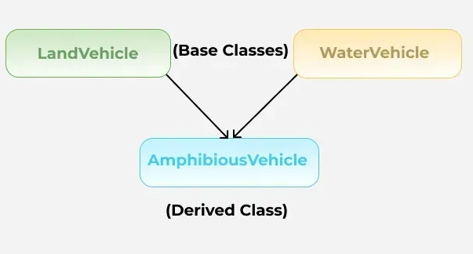
Example:
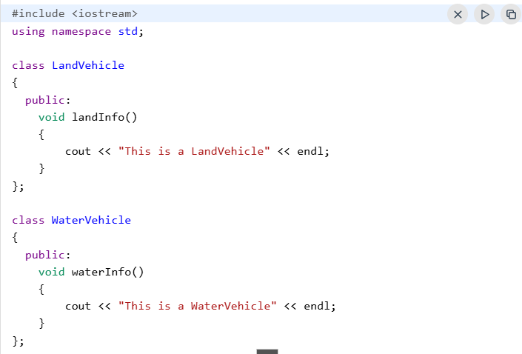
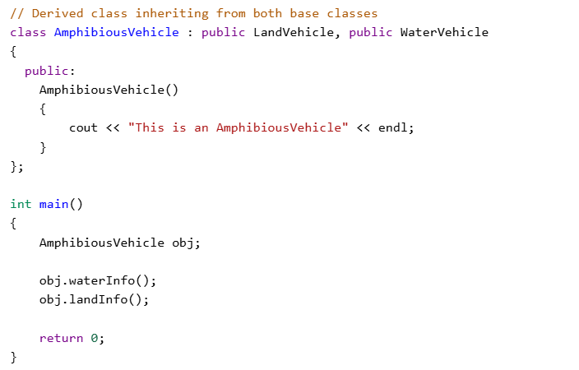
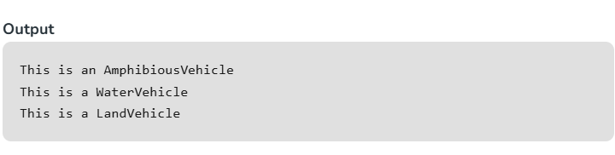

Hierarchical Inheritance
In hierarchical inheritance, more than one subclass is inherited from a single base class. i.e. more than one derived class is created from a single base class. For example, cars and buses both are vehicle.
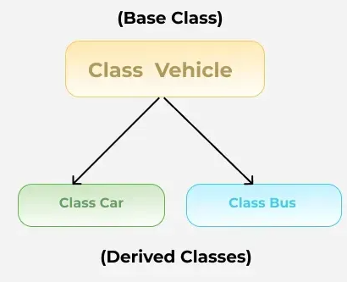
Example:
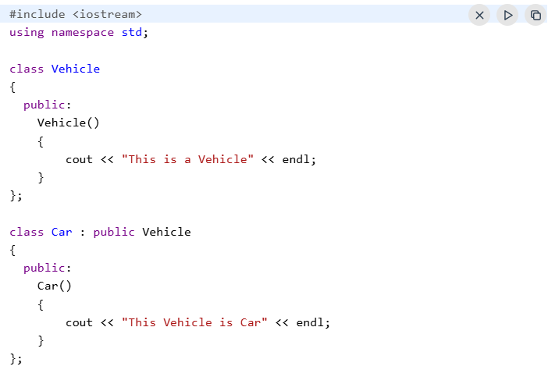
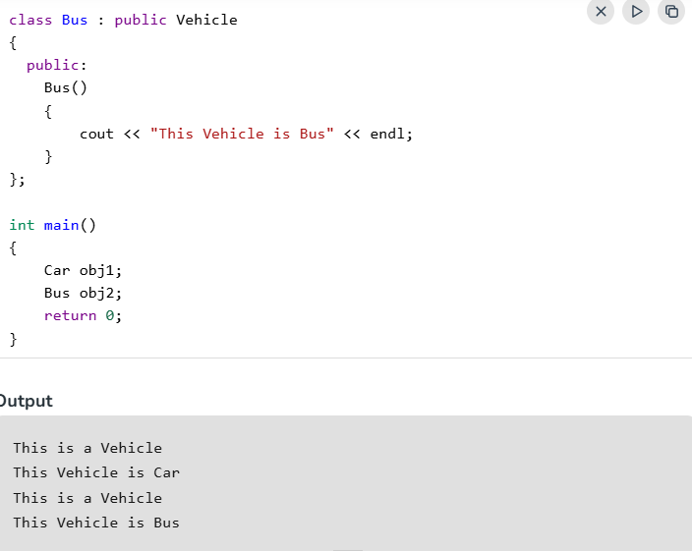

Hybrid Inheritance
When two or more types of inheritance are combined in one program. For example, a class might use multiple inheritance and also be part of a multilevel inheritance chain.
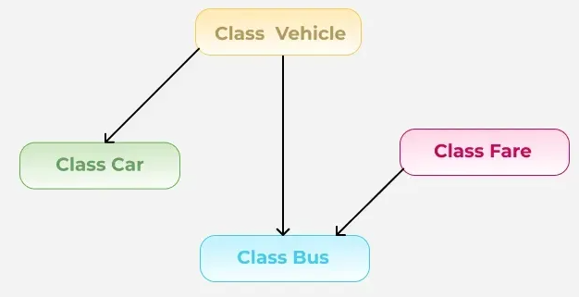
Example:
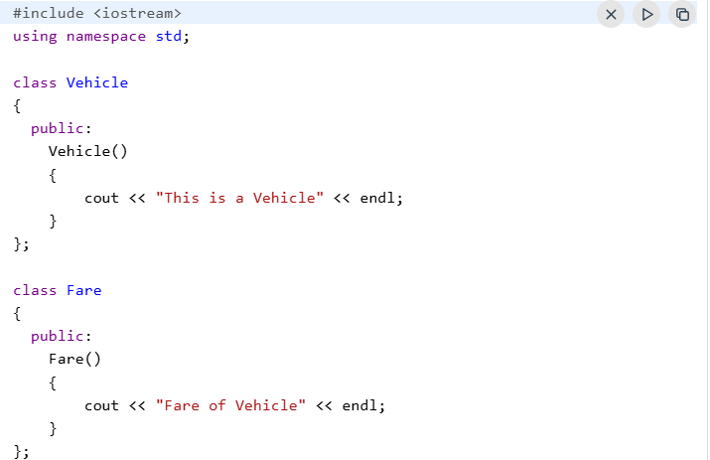
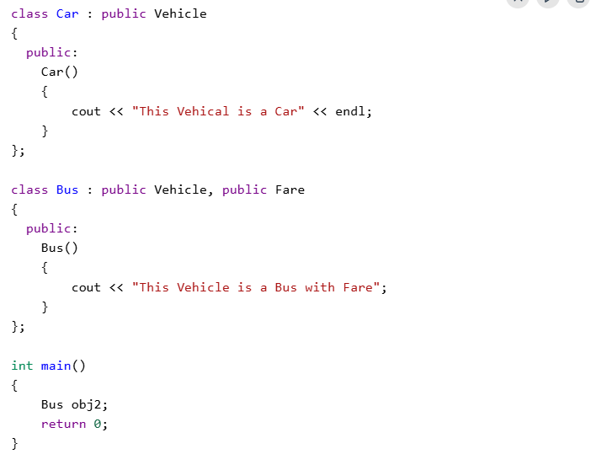
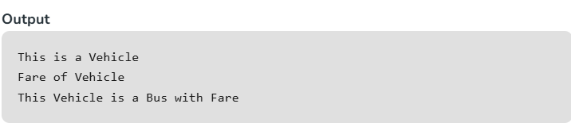
Note:
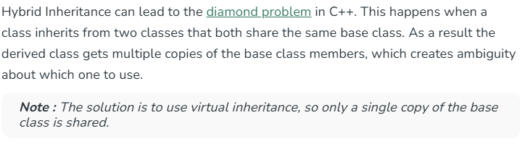

Lab Tasks
Hierarchical Inheritance:
Task 1: Book, EBook, AudioBook, PaperBook (20 mark)
See the following class diagram of Book, ElectronicBook, AudioBook, & PaperBook and implement inheritance relationship of classes in python.
You need to implement following items for each class;
- Constructors
- Setters
- Getters
- Member Methods

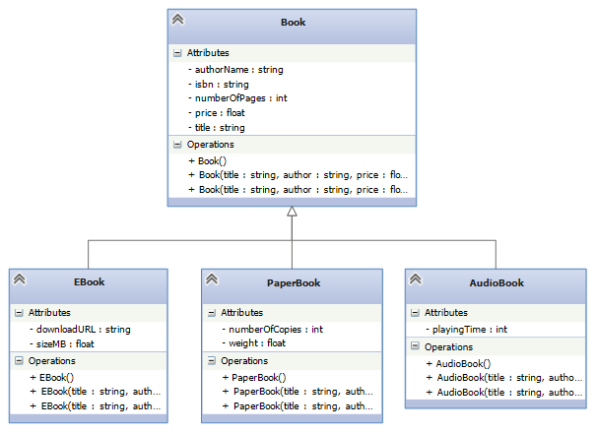
(Paste your code here)
CODE:
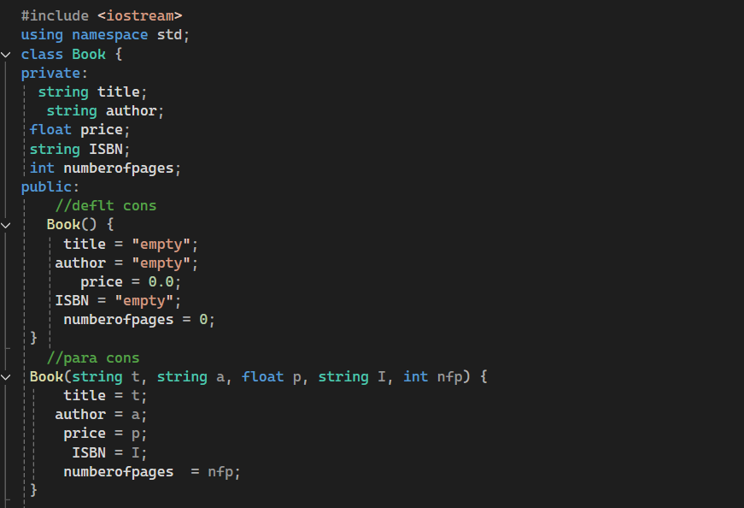
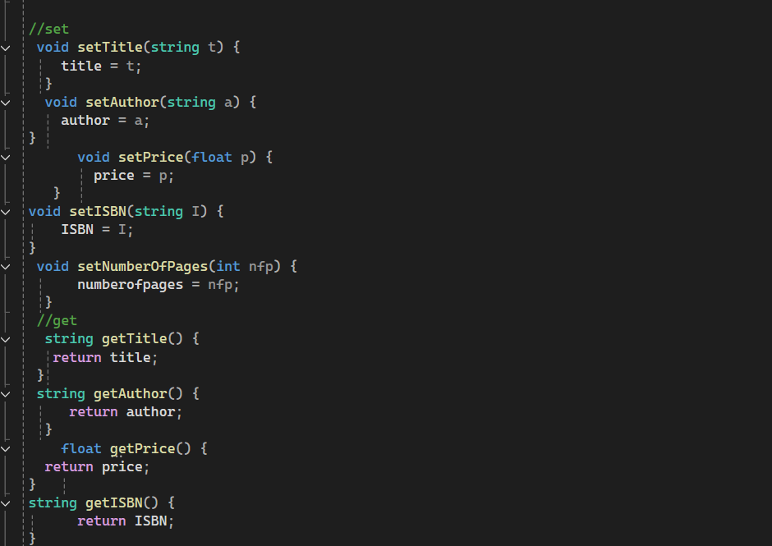
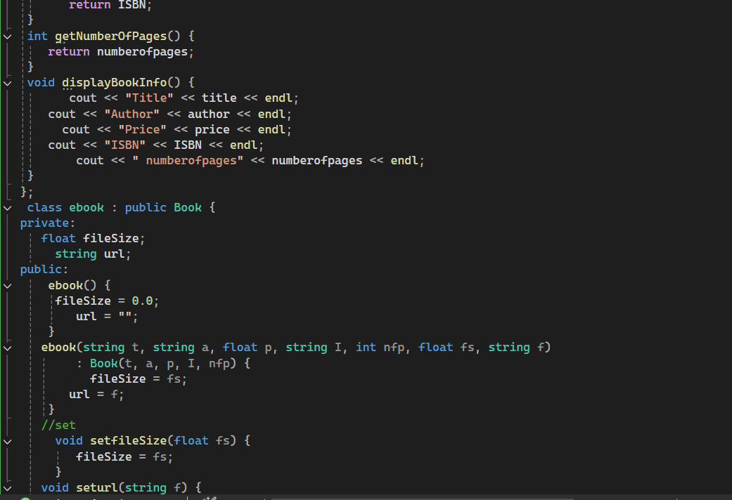
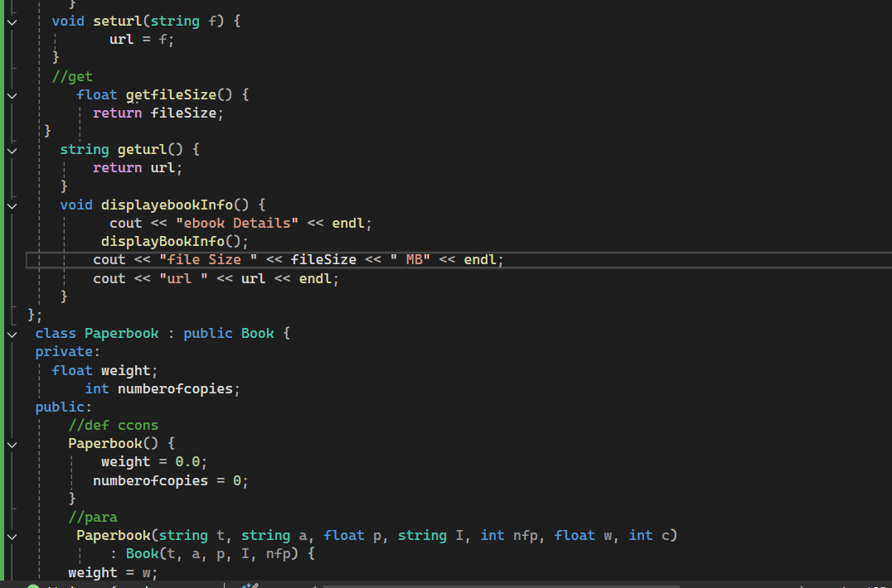
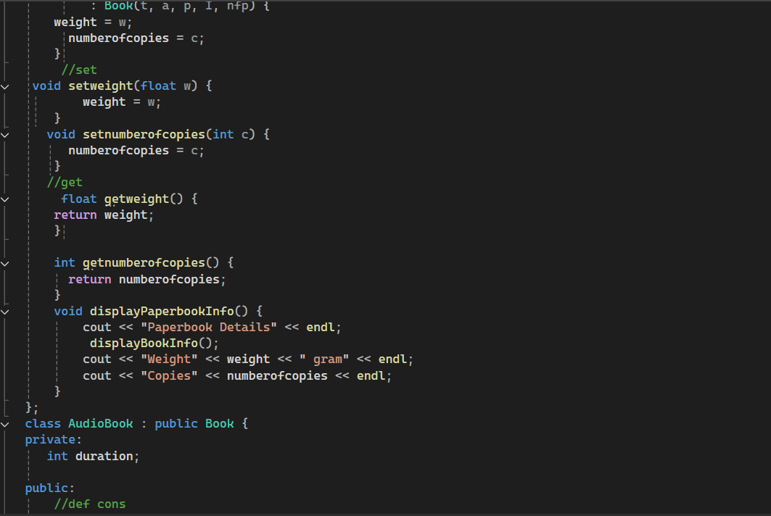
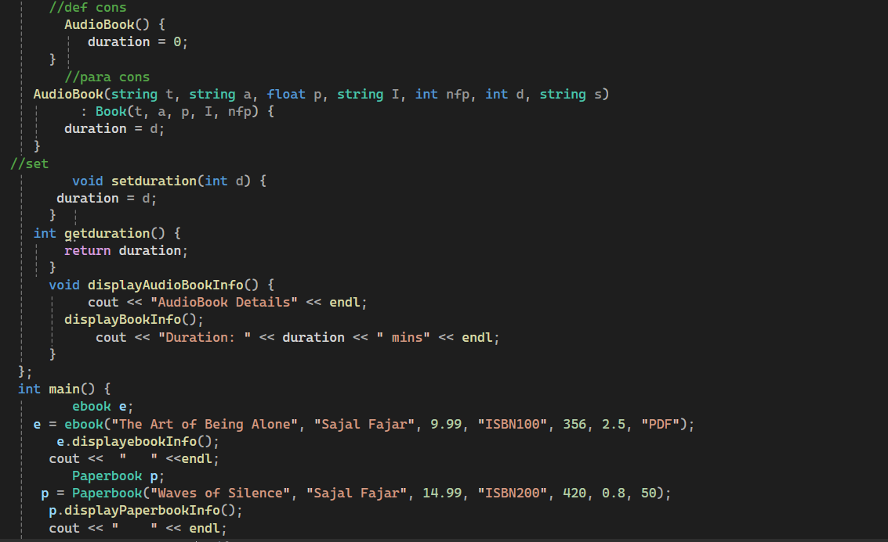
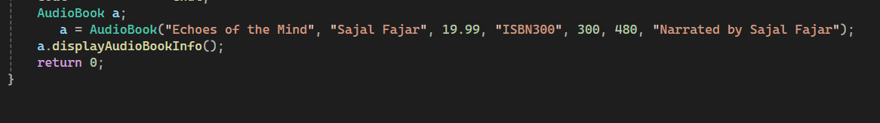
OUTPUT:

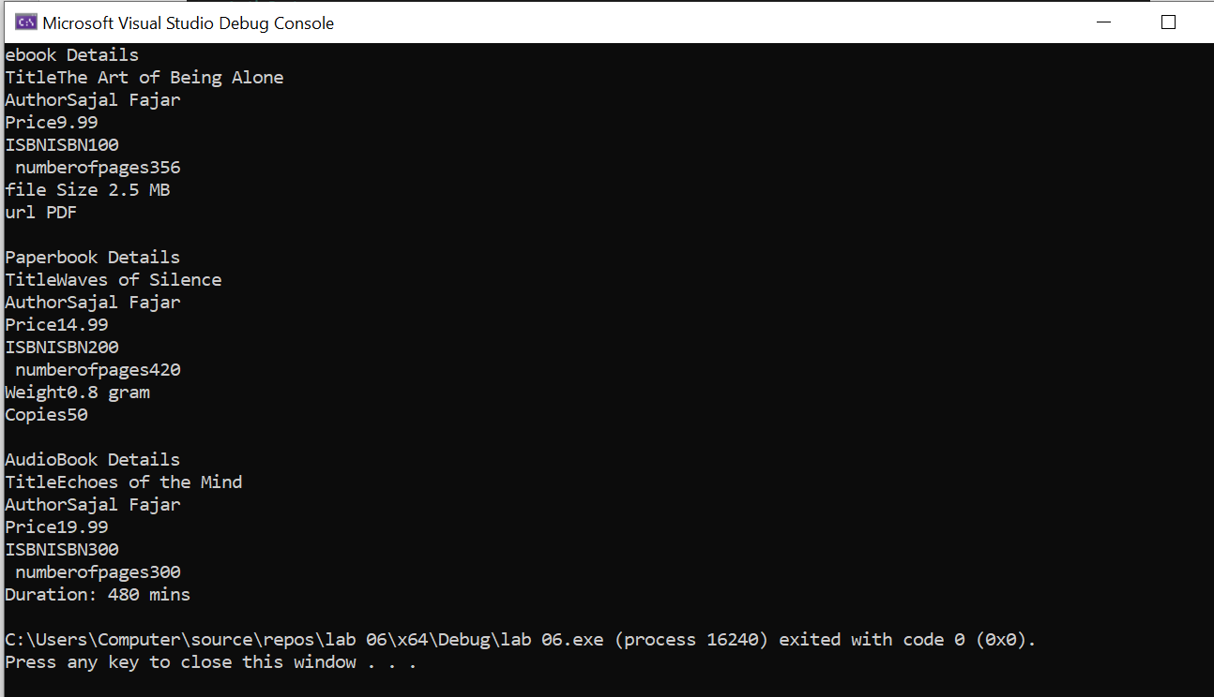

Task 2: Multiple Inheritance (20 mark)

See the following class diagram and implement multi-level inheritance relationship of classes in C++.
You need to implement following items for each class;
- Constructors
- Setters
- Getters
- Member Methods
Demonstrate working of your classes.
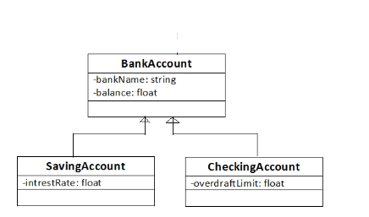
CODE:
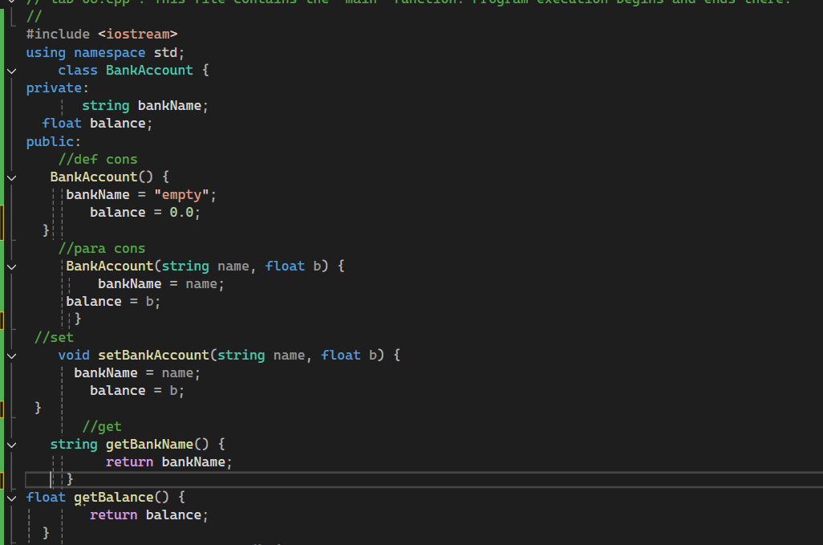
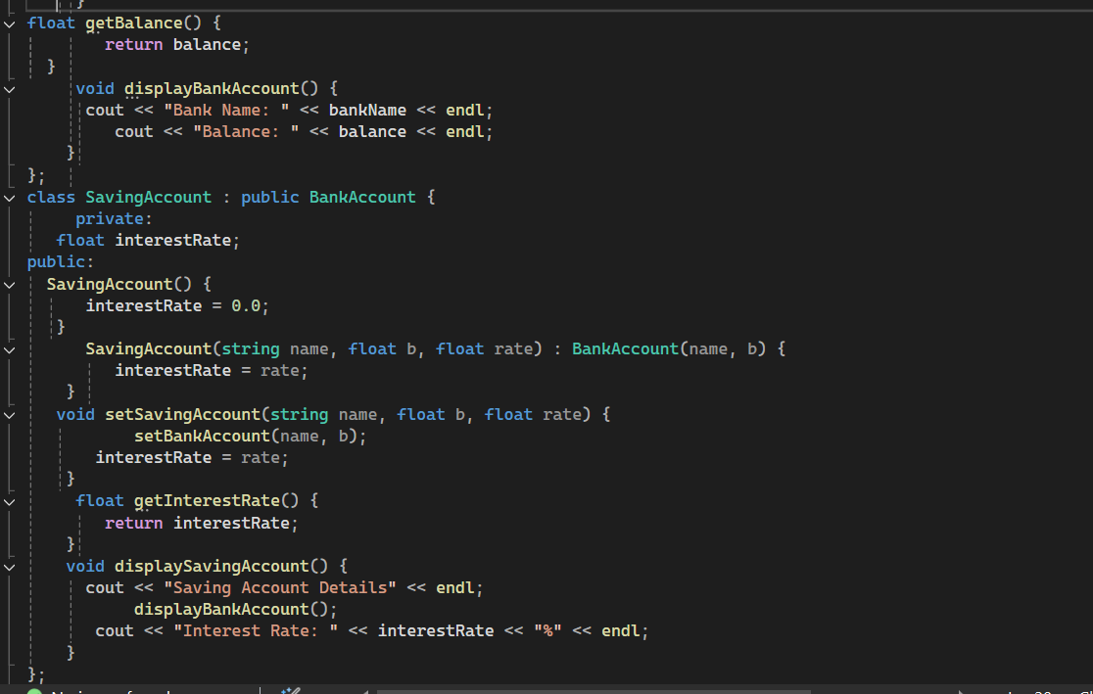
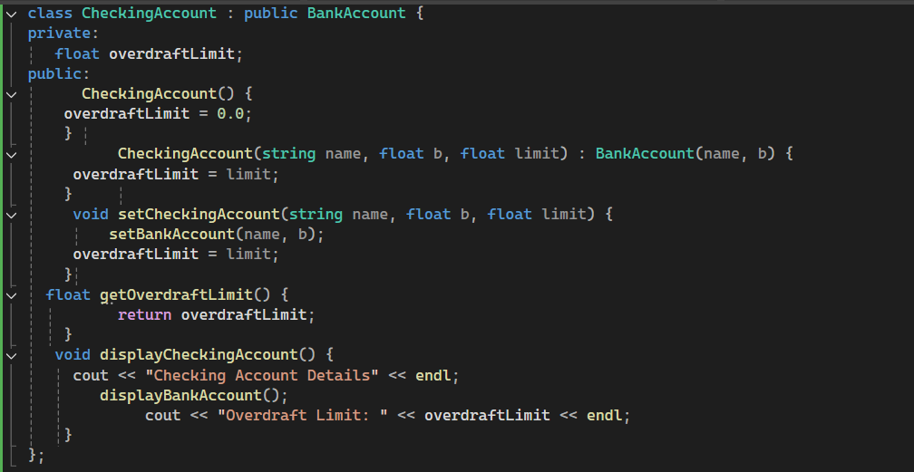
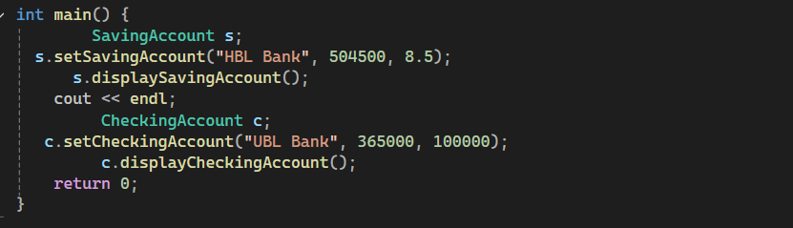
OUTPUT:
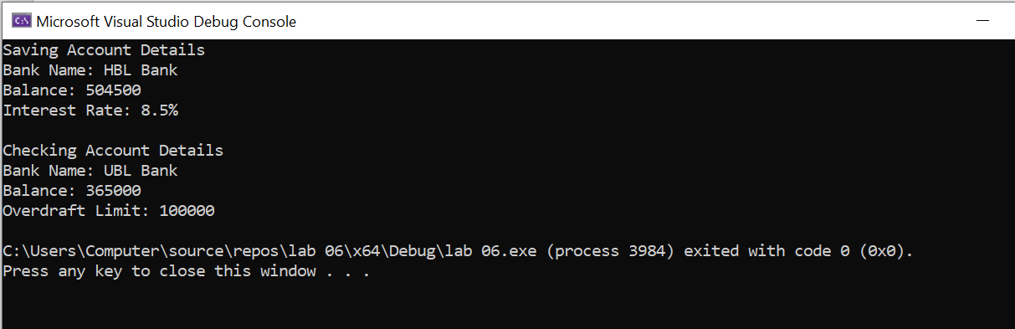

Task 3: Hybrid Inheritance (20 mark)
See the following class diagram and implement multiple inheritance relationship of classes in C++.
You need to implement following items for each class;
- Constructors
- Setters
- Getters
- Member Methods
Demonstrate working of your classes.
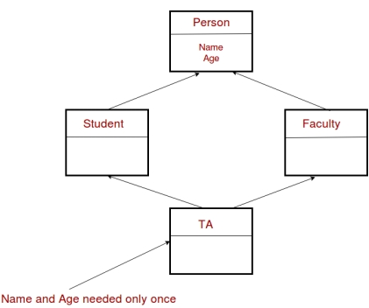
CODE: 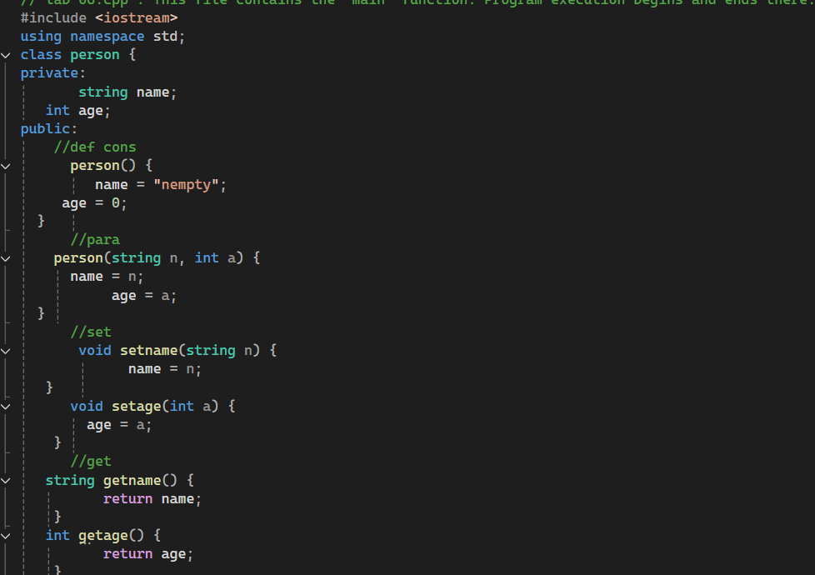
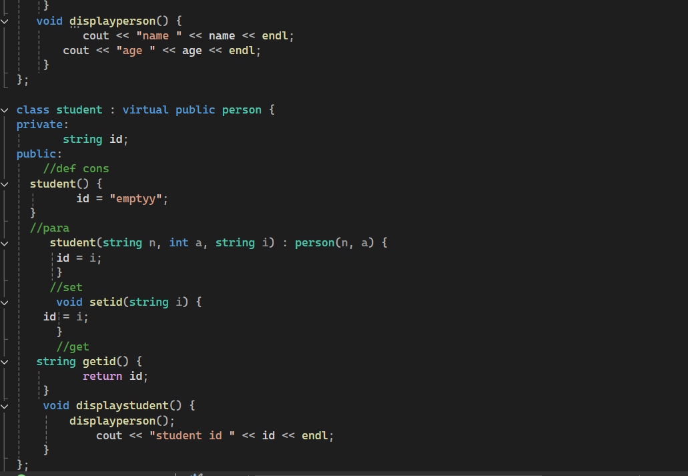
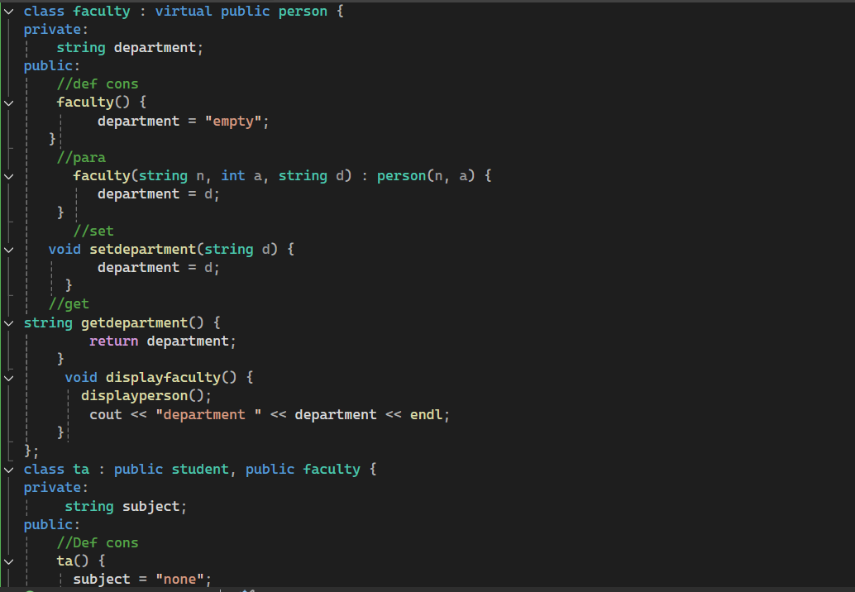
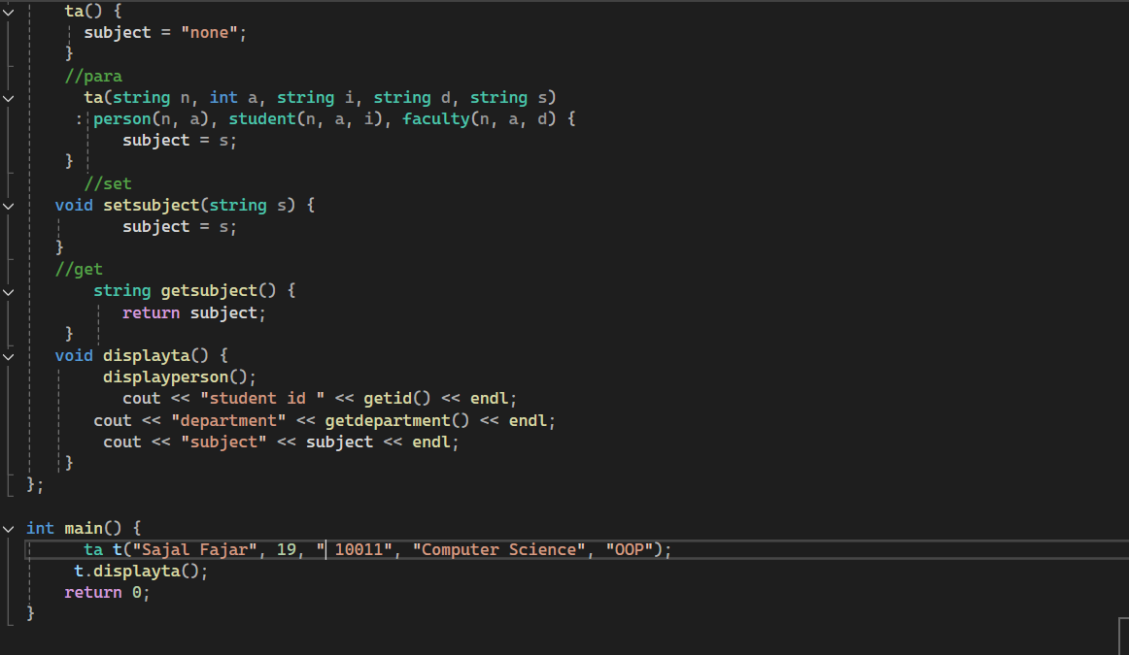

OUTPUT:
